Question 2 – Optimization Using Simulated Annealing
CSE 351 – Artificial Intelligence, Fall 2026
1. What we Did
For this question we implemented Simulated Annealing (SA) to try to find the global minimum of three test functions: Booth, Himmelblau and Griewank. we started with the parameter values given in the assignment (neighborhood step size = 0.5, starting temperature T = 1 decaying by 0.1 every K = 100 iterations), and ran the algorithm on all three functions for 1000 iterations.
Booth and Himmelblau converged to their correct minimum almost every time I ran them, so I didn't have to touch anything there. Griewank was a different story - with the same starting values it kept wandering around and never actually settled down. So most of this report is about the plots I got with the original settings, and then the back-and-forth I went through to fix Griewank, including the reasoning (and a bit of math) behind each change.
2. Quick Recap of How the Algorithm Works
The code starts at a random point (x, y) and repeatedly tries a nearby point by nudging x and y by a random amount within the step size (±0.5 in this case). If the new point gives a lower (better) value of f(x, y), it is always accepted. If the new point is worse, it can still be accepted, but only with a certain probability, which depends on how much worse it is (delta) and the current temperature T:
P(accept a worse move) = e^( -delta / T )
This is the idea behind Simulated Annealing, at high temperature the algorithm is willing to accept bad moves so it can explore and escape from local traps, and as T cools down it becomes stricter and only accepts moves that actually improve the result, so it settles ('freezes') into a minimum. Every K = 100 steps, the temperature is reduced, and the loop keeps going until T drops below 0.001.
3. Booth Function
f(x, y) = (x + 2y − 7)² + (2x + y − 5)² for −10 ≤ x, y ≤ 10
This function has one global minimum, at (x, y) = (1, 3), where f = 0.
I can check this by hand: plugging in x = 1, y = 3 gives:
(1 + 6 − 7)² + (2 + 3 − 5)² = (0)² + (0)² = 0
so that confirms it.
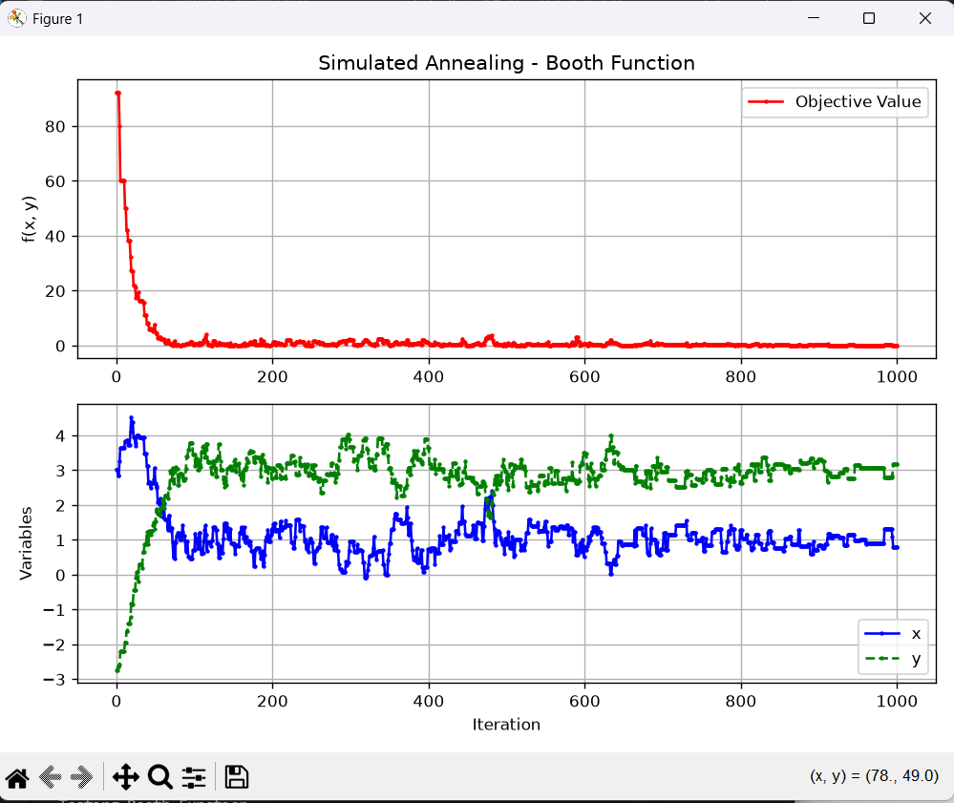
Figure 1: Simulated Annealing on the Booth function (1000 iterations, T = 1, decay = 0.1, K = 100, step = 0.5)
The top graph is the objective value f(x, y) at every iteration, and the bottom one shows how x (blue) and y (green) move around while the search is happening.
In the first 100 iterations or so, f drops from around 90 all the way down to nearly 0, and after that it basically stays flat with just tiny bumps here and there. If you look at the bottom plot, x starts off close to -2.5 and climbs up towards 1, while y starts near 9 and comes down towards 3 - which is exactly the (1, 3) point we calculated above. Because Booth is just a smooth bowl shape with a single minimum, once the algorithm finds the slope heading downhill it basically just rides it straight to the bottom, so this one converges fast and cleanly.
4. Himmelblau Function
f(x, y) = (x² + y − 11)² + (x + y² − 7)² for −5 ≤ x, y ≤ 5
Himmelblau is a bit more interesting because it doesn't have just one minimum - it has four, and all four give f = 0. They sit at roughly (3, 2), (-2.81, 3.13), (-3.78, -3.28) and (3.58, -1.85). Since SA just needs to find any global minimum (not a specific one), which of the four it lands on just depends on where it happens to start and which direction the random moves push it in the beginning.
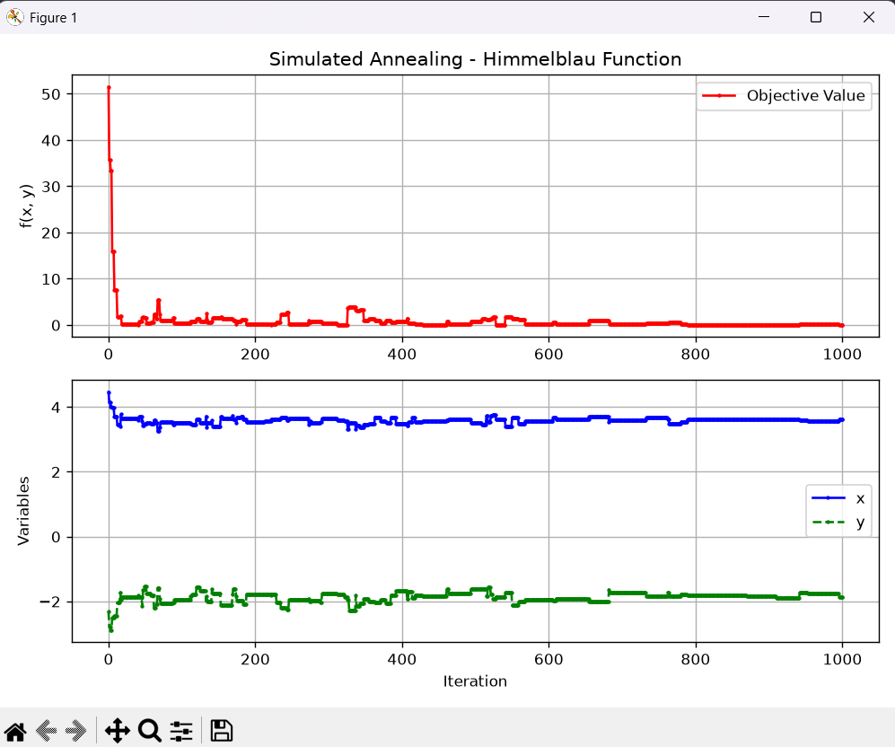
Figure 2: Simulated Annealing on the Himmelblau function (1000 iterations, same starting parameters)
Same layout as before - f(x,y) on top, x and y on the bottom. Here f starts above 50 and drops to almost 0 within the first ~50 iterations, then stays close to zero with only small spikes (there's a slightly bigger one around iteration 330-340, which is just the algorithm accepting a temporarily worse move because the temperature hadn't fully cooled yet).
Looking at the bottom plot, x settles at roughly 3.6 and y settles at roughly -1.8. That's actually the fourth minimum I listed above, (3.58, -1.85), not the (3, 2) one - it's easy to assume it's the "main" one since that's the pair usually quoted first, but the run just happened to fall into that corner instead. Either way, f is basically 0 there, so the algorithm still did its job correctly - it just picked a different one of the four equally good answers.
5. Griewank Function - First Attempt (Original Parameters)
f(x, y) = 1 + (x² + y²)/4000 − cos(x)·cos(y/√2) for −30 < x, y < 30
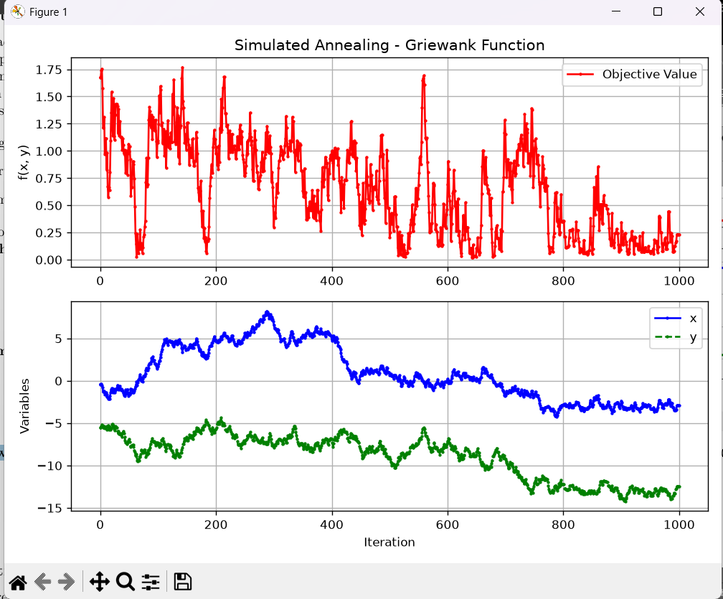
Figure 3: Griewank with the original parameters (T = 1, decay = 0.1, K = 100, step = 0.5, 1000 iterations)
The top graph never flattens out - it keeps bouncing between roughly 0 and 1.75 for the full 1000 iterations. The bottom graph shows x and y drifting around a big range (x roughly between -3 and 7, y between -13 and -5) without ever settling near a fixed point. Since the true minimum is at (0, 0), this run clearly never got there.
Why does this happen?
The Griewank formula is two pieces added together, and they pull in opposite directions:
- The bowl part, (x² + y²)/4000, is a smooth surface that slowly increases the farther you get from (0,0). By itself it would just be one giant, the search would slide straight to the middle.
- The wave part, -cos(x)·cos(y/√2), oscillates between -1 and +1. Because cosine repeats itself, this creates a grid of small bumps and dips across the entire surface, kind of like an egg carton laid on top of the bowl.
cos(x) repeats every 2π ≈ 6.28 units, and cos(y/√2) repeats every 2π√2 ≈ 8.89 units, so a new little dip shows up every few units in both directions. Near the edges of the domain (x, y close to ±30) the bowl term is large enough that it dominates and you can still slide downhill. But close to the centre, the bowl term becomes tiny (much less than 1), so the cosine bumps are just as deep as the real minimum at (0,0). That means the search can easily get stuck thinking it has found the bottom, when really it has just fallen into one of the thousands of small local dips scattered around the middle of the domain.
On top of that, with T only starting at 1 and cooling by 0.1 every 100 steps, the temperature runs out after just 10 stages (1000 iterations total). That's nowhere near enough "heat" for the algorithm to jump out of these dips and travel all the way back to the real centre, so it just freezes wherever it happens to be when T hits zero.
6. Fine-Tuning the Parameters
Since the problem was clearly the temperature and cooling schedule not giving the search enough freedom to escape the local dips, I tried adjusting the starting temperature and the cooling rule step by step and looked at how the graphs changed each time.
Attempt 1: Raise the starting temperature to T = 10
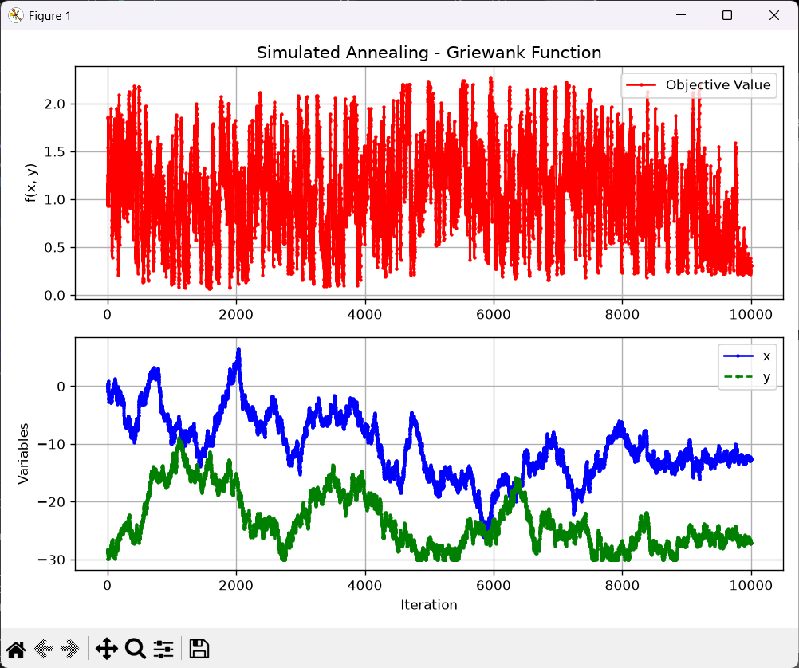
Figure 4: Griewank with T = 10, decay = 0.1, K = 100, step = 0.5 (10,000 iterations)
Raising T to 10 (decay still 0.1) means the search now runs for 10,000 iterations instead of 1000 before T reaches 0. The red curve still jumps around a lot for most of the run, but towards the very end (past iteration 9000 or so) it does start dropping down and flattening out a bit, and the bottom plot shows x and y beginning to settle into a narrower band. So this was an improvement, but not really a fix - it still spends almost the whole run just wandering.

Attempt 2: T = 50 (still decay = 0.1)
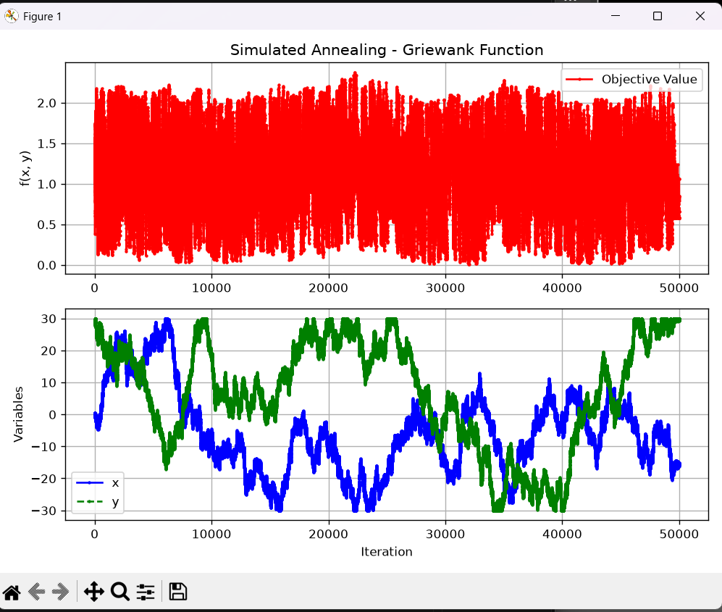
Figure 5: Griewank with T = 50, decay = 0.1 (50,000 iterations)
I pushed the starting temperature further, to T = 50. But with decay = 0.1 that means going from T = 50 down to 0 takes 500 stages of 100 iterations each - 50,000 iterations. The graph shows why that's a problem: x and y just roam across almost the entire domain (from close to -30 up to +30) and never come close to converging, and f keeps oscillating the same way the whole time.
The reason is the acceptance probability formula. If a move makes things worse by, delta = 0.5, then:
- At T = 1: P = e^(-0.5/1) = e^-0.5 ≈ 0.61 → about 61% chance of accepting the bad move.
- At T = 50: P = e^(-0.5/50) = e^-0.01 ≈ 0.99 → about 99% chance of accepting the bad move.
So at T = 50, almost every move gets accepted, good or bad. For most of those 50,000 iterations, T is still sitting somewhere between 10 and 50, which is still "too hot" - the algorithm is basically doing a random walk over the whole domain instead of actually searching. Raising T on its own just makes it explore more without ever settling down.
Attempt 3: T = 50, but decay by 1.0 per stage (linear)
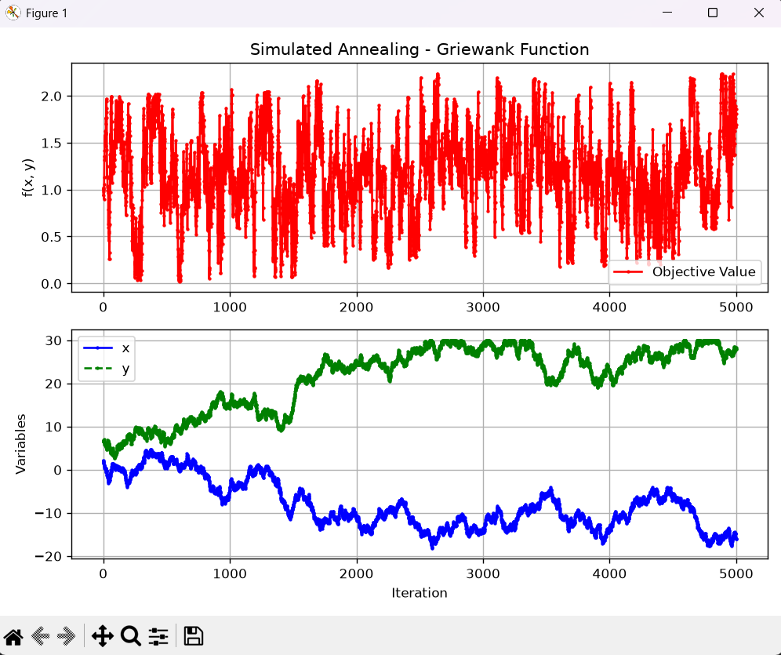
Figure 6: Griewank with T = 50, linear decay of 1.0 per stage, K = 100, step = 0.5 (5,000 iterations)
Next I kept T = 50 but sped up the cooling by subtracting 1.0 from the temperature every stage instead of 0.1, so it now cools down in 5,000 iterations. This is faster, but the graph is still messy - x and y drift from around 0 up towards 25-30 and stay there, never coming back towards the centre. The issue here is that linear decay (T = T - 1) treats every stage the same, whether T is 50 or T is 2. That means it drops in a straight line from 50 all the way to 1 and then jumps straight to 0 in the very last step. There's no "slow, careful" phase near the end where T is small - it just cuts off abruptly, so the search never gets the fine-tuning time it needs at low temperature to actually lock onto a minimum.

Attempt 4: T = 50, exponential decay method (T = T × 0.95)
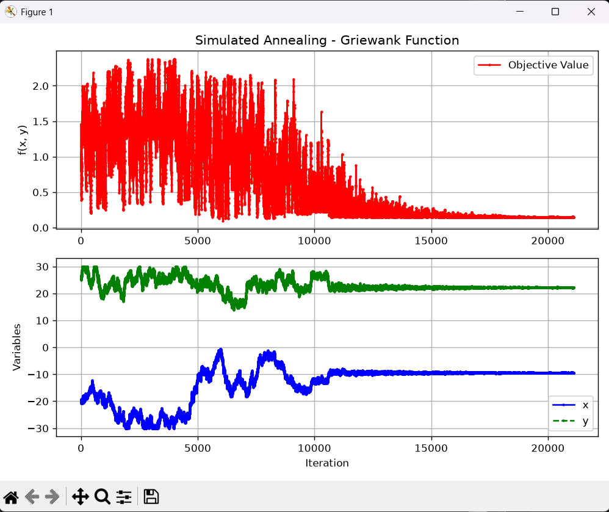
Figure 7: Griewank with T = 50, exponential decay (T = T × 0.95 every K = 100 iterations), step = 0.5 (~21,000 iterations)
The fix that actually worked was switching from a fixed linear decay to a percentage-based (exponential) one, where the temperature is multiplied by 0.95 at the end of every stage instead of having a fixed amount subtracted. This gives a schedule that cools down fast at first, and then very slowly once T gets small - which is exactly the behavior we want:
- Going from T = 50 to T = 1 only takes about 190 iterations of the cooling loop, because at high T even a 5% cut is a big absolute drop (50 → 47.5 → 45.1 → ...).
- But going from T = 1 down to T = 0.001 (the stopping point) takes roughly 135 more stages, because a 5% cut of a small number is a tiny absolute drop (1 → 0.95 → 0.90 → ... → 0.001). This gives the search hundreds of low-temperature stages to fine-tune its position instead of just one abrupt jump to zero.
You can actually see this in the graph: for the first 10,000 iterations or so, f is still bouncing around between 0 and 2 while x and y are searching (x moves between about -25 and 5, y between about 15 and 30). But after roughly iteration 12,000-13,000, both lines flatten out almost completely, and f settles down to a small, steady value of around 0.15-0.2 for the rest of the run, with x sitting close to -9 and y close to 22.
It's worth being honest here - this final value (around 0.15) is very small but it isn't exactly 0. That's because the point (-9, 22) is one of the many small local dips created by the cosine ripples described in Section 5, and it happens to be a fairly deep one, but not the exact global minimum at (0,0). If I re-ran the same code with a different random seed, it's likely to settle in a different nearby dip with a similarly low value.
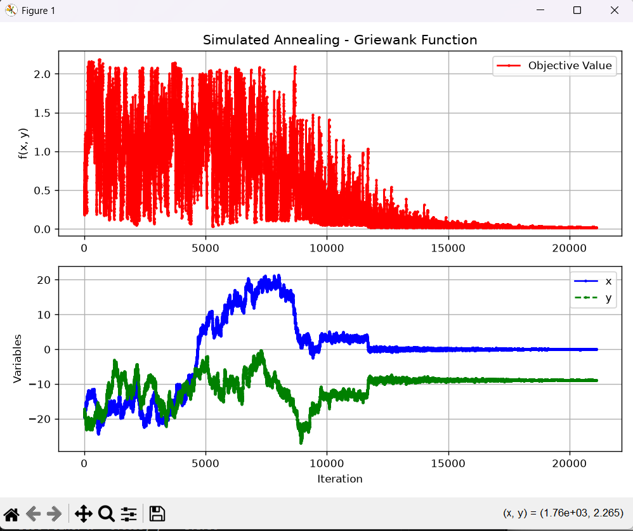
Here, we can see that the global minimum is found at zero. The takeaway isn't that this exact parameter set guarantees hitting (0,0) every time - it's that a high starting temperature paired with slow exponential cooling gives Griewank a realistic chance of getting very close to the global minimum instead of getting permanently stuck in the first dip it stumbles across, which is what was happening with the original parameters.
OTHER TWO FUNCTIONS WORK FINE WITH THSES VALUES TOO:

Booth function:
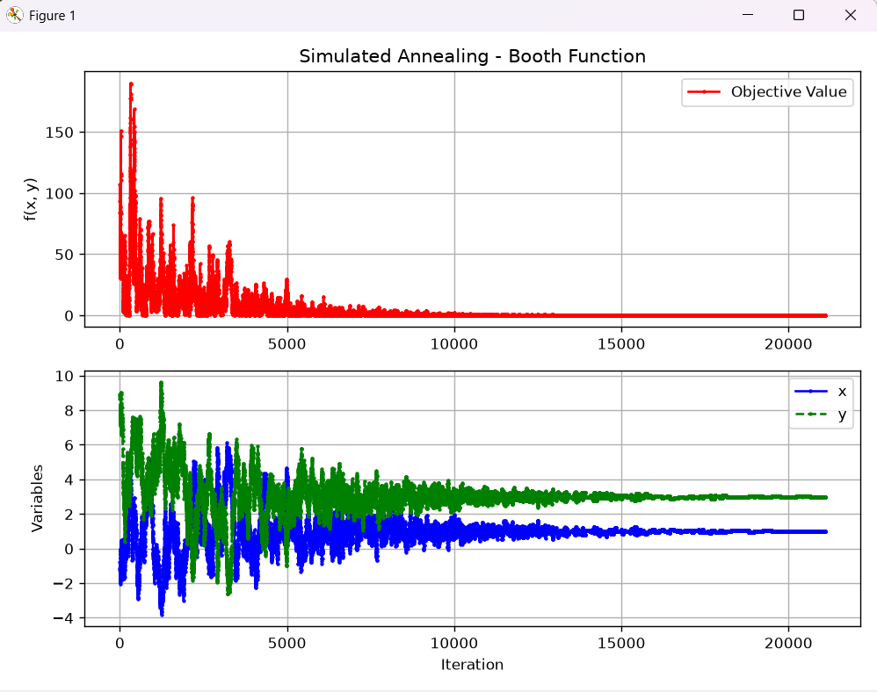
Himmelblau Function:
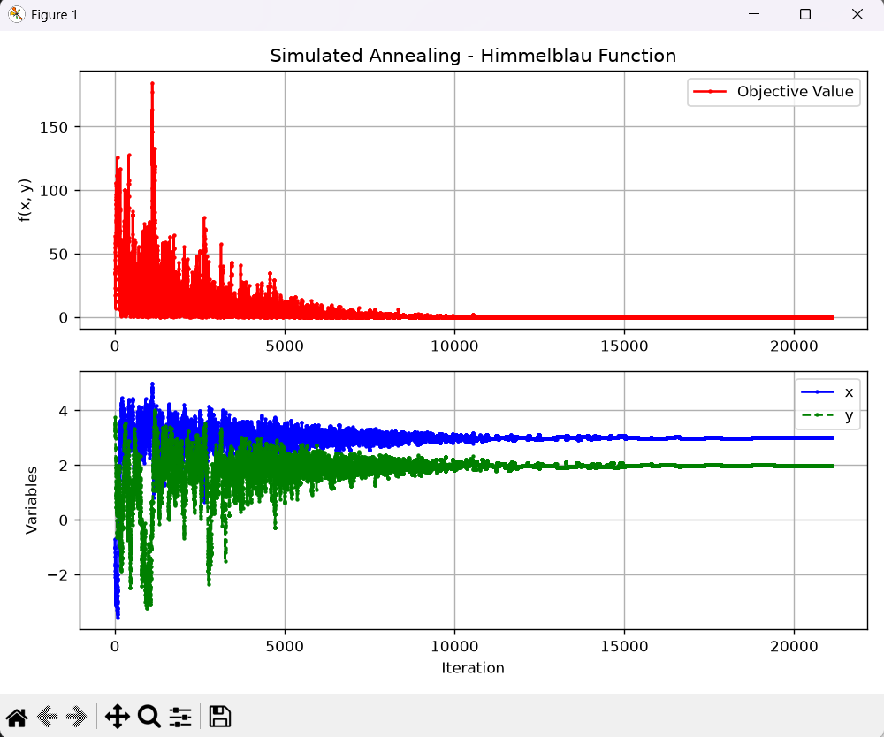

SUMMARY:
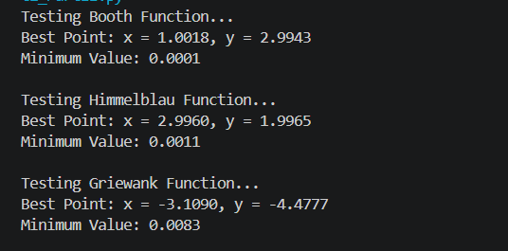
7. Final Parameters decided
Based on all of the above, the final version of the code uses the following settings, which are now the defaults in the run_simulated_annealing function:
Parameter | Assignment's Starting Value | Final Value Used
Starting temperature (T) | 1.0 | 50.0
Cooling schedule | Linear, T = T − 0.1 every K steps | Exponential, T = T × 0.95 every K steps
Iterations per stage (K) | 100 | 100 (unchanged)
Neighborhood step size | 0.5 | 0.5 (unchanged)
K and the step size didn't need to change - the real problem was always how the temperature was scheduled, not how big a step the algorithm was allowed to take or how many tries it got per temperature stage. Since these final settings are just a slower, longer version of the same idea (still a bowl-shaped acceptance rule, just stretched out over more iterations), Booth and Himmelblau still converge correctly with them - they just take a bit longer to freeze than they did with the original settings, since it now takes ~21,000 iterations for T to fully cool down instead of 1,000.
8. Summary of Results
Function | Known Global Minimum | Result Found by SA | Converged?
Booth | (1, 3), f = 0 | x ≈ 1.0, y ≈ 3.0, f ≈ 0 | Yes
Himmelblau | 4 points, all f = 0 | x ≈ 3.58, y ≈ -1.85, f ≈ 0 | Yes (found one of the 4 minima)
Griewank (original params) | (0, 0), f = 0 | kept wandering, never settled | No
Griewank (tuned params) | (0, 0), f = 0 | x ≈ -9, y ≈ 22, f ≈ 0.15-0.2 | Close, but sometimes stuck in a nearby local dip rather than the exact global minimum

